2. Install Jenkins (as a service)

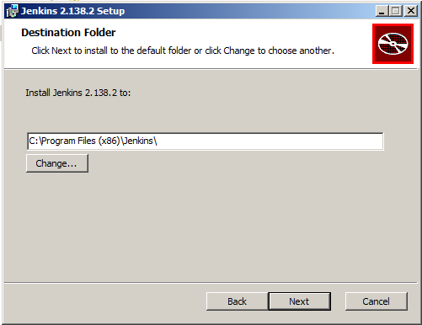

3. Install JDK, Maven, Ant

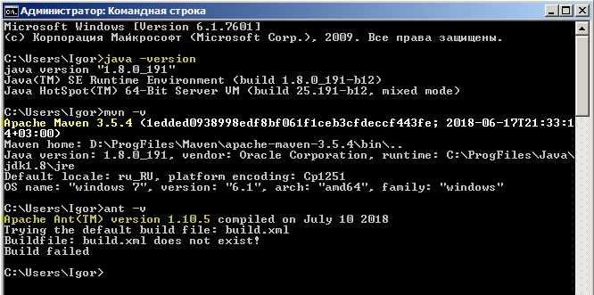

**4.** Configure Jenkins with installed JDK, Maven, Ant. **5**… additional JDK (auto-installed)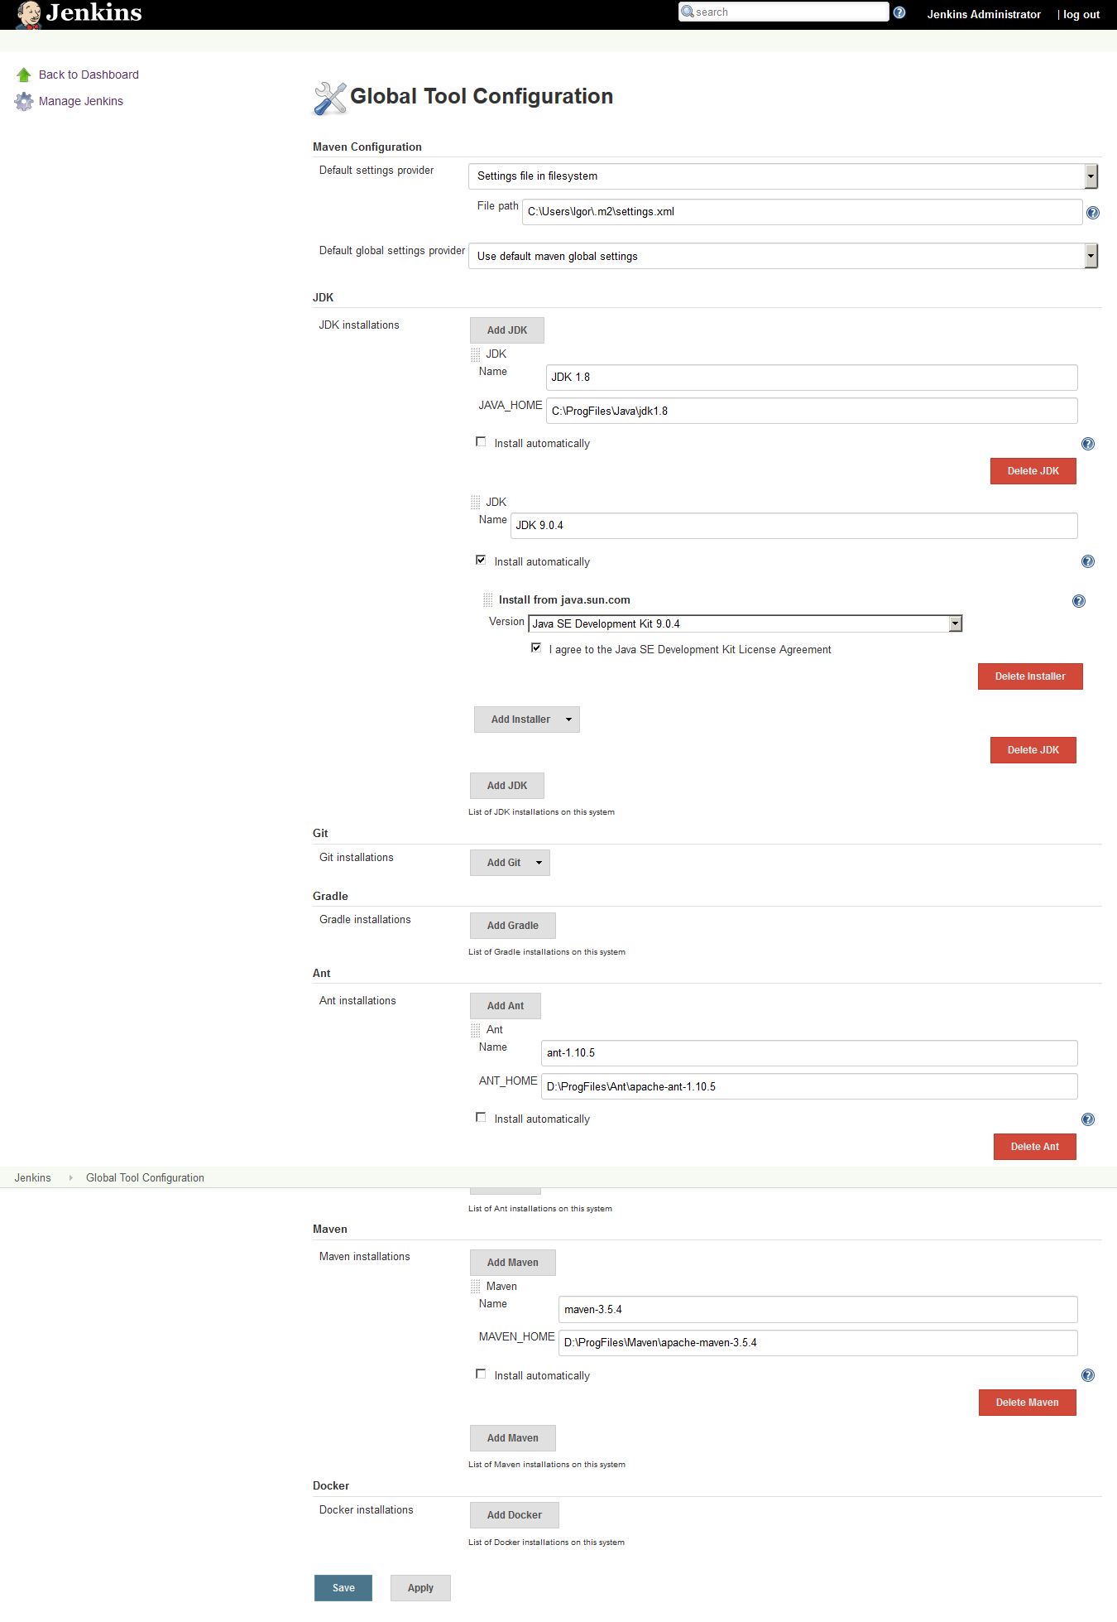

6. Install 10 Jenkins plugins (Git, Parametrized trigger, email-ext, Scriptler, Groovy post-build, Green Balls etc.)

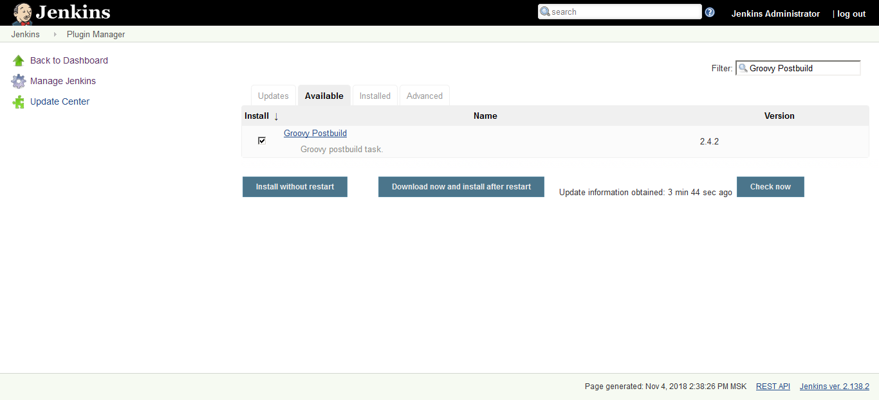

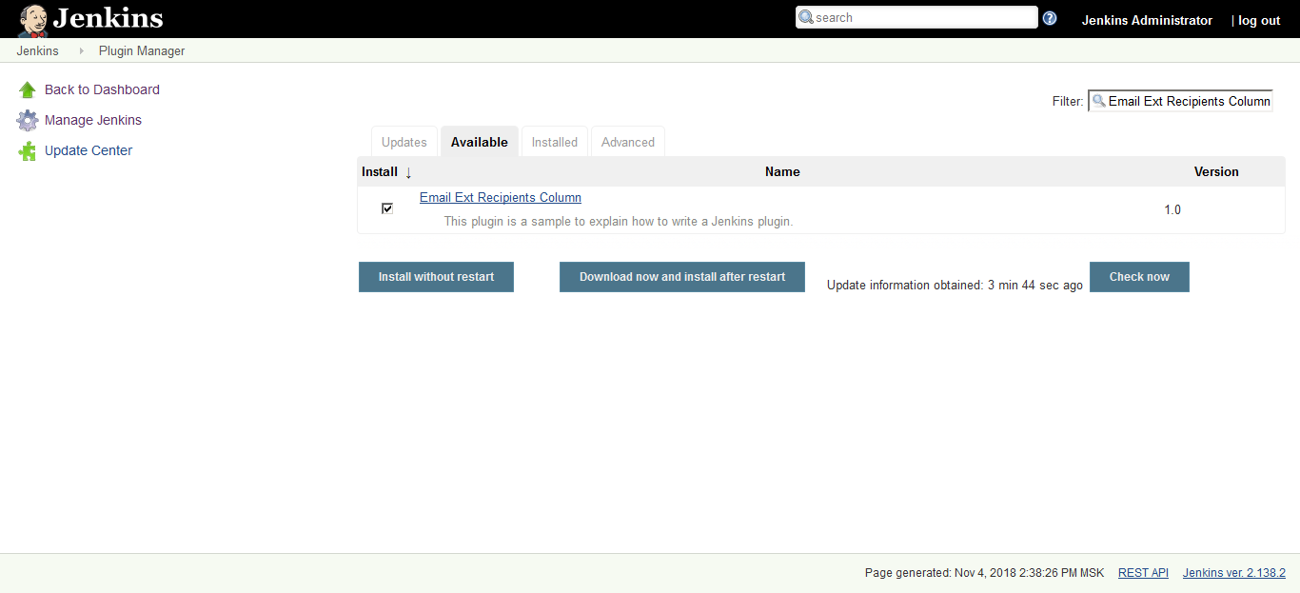

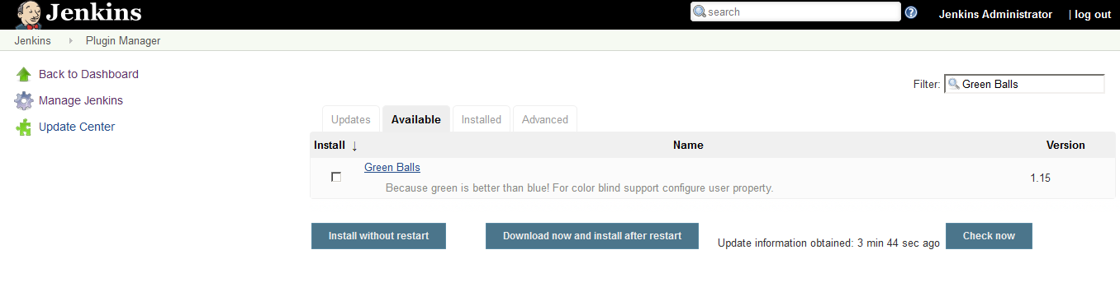

7. Configure Jenkins security (install Role strategy plugin). Remove anonymous access. Create administrator user (all permissions) and developer user (build job, cancel builds)

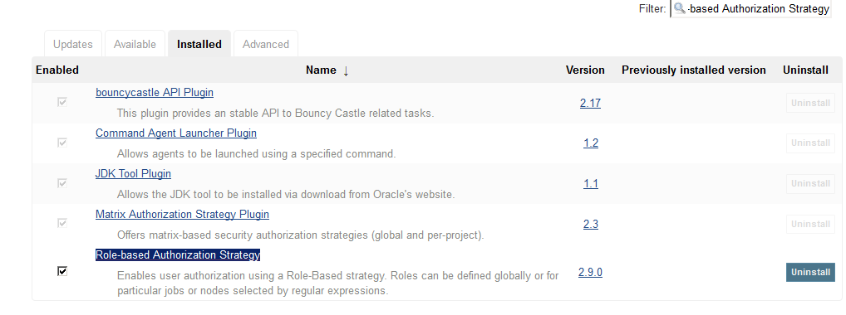

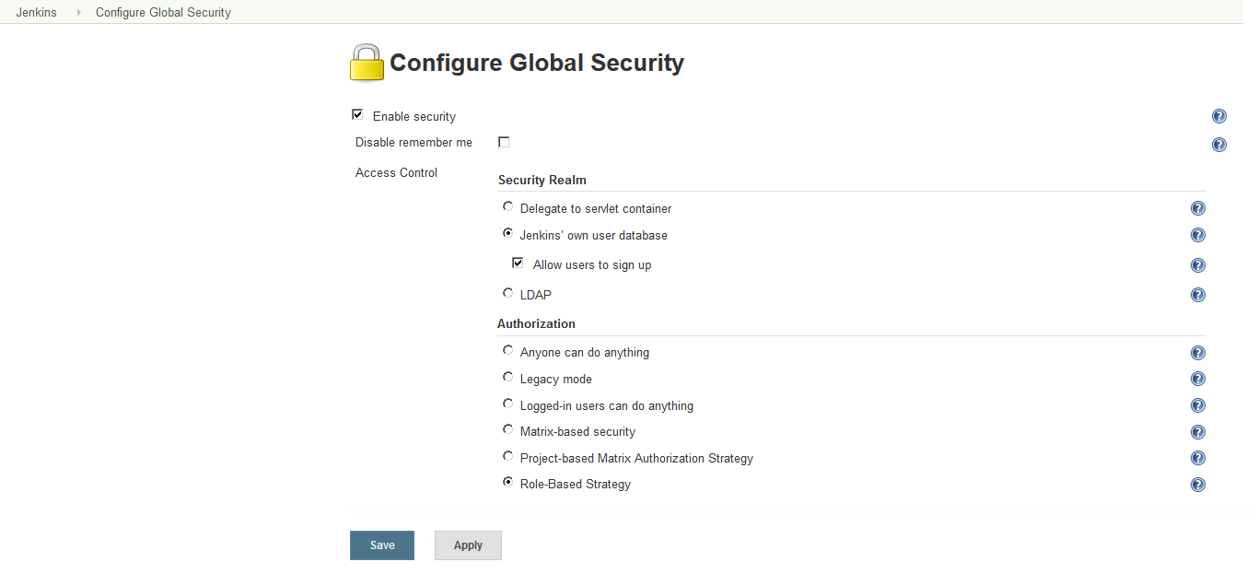

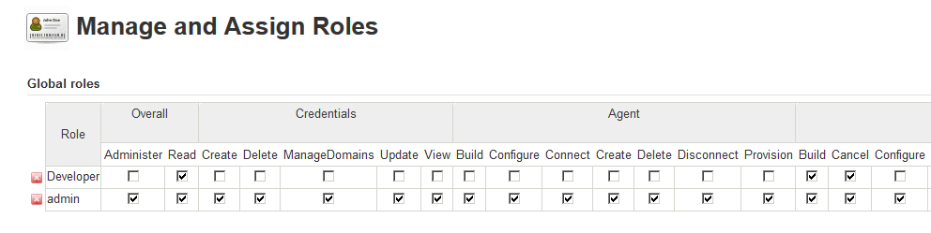

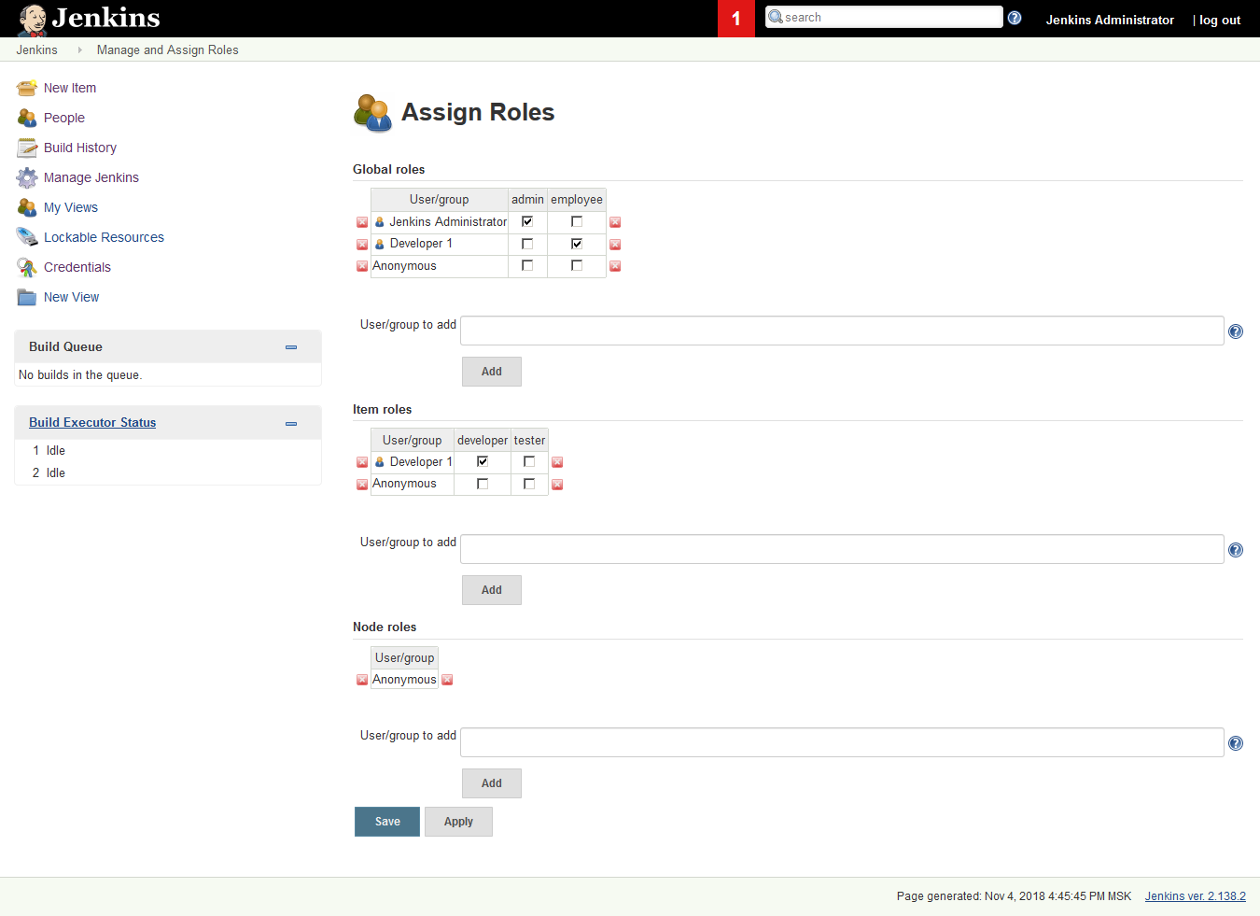

8. Create simple free-style job

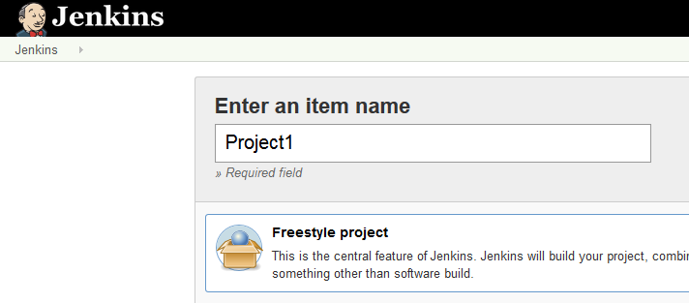

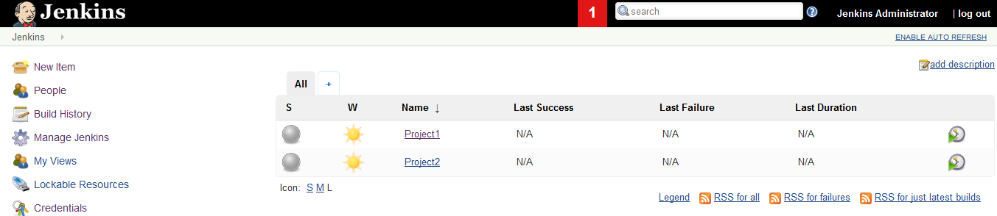

9. Setup simple trigger and build action (echo current build number)

